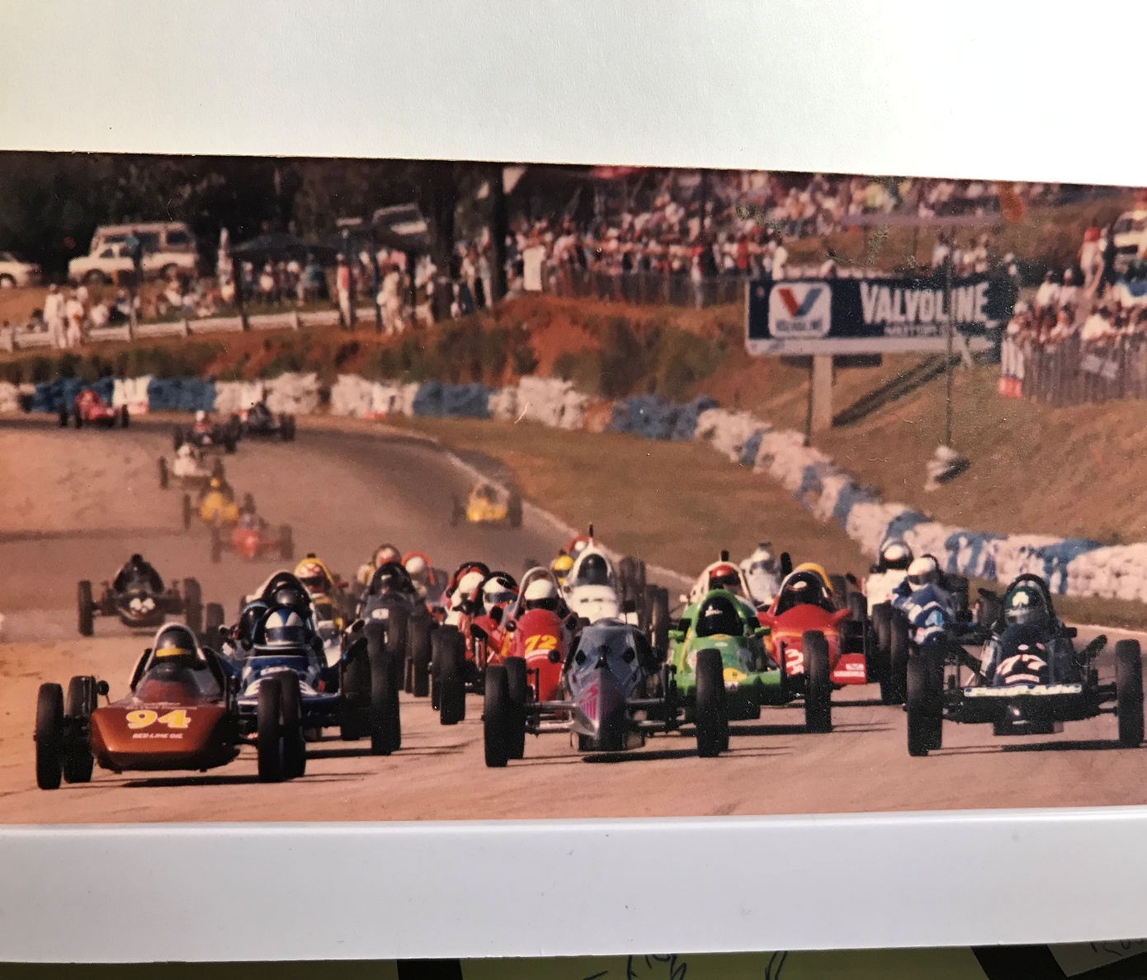
Blast from the past. The author (right, 77) joins Bob Numeister (left, 94) and George Fizell (center, 33) at the start of the 1988 SCCA Runoffs at Road Atlanta.
Catching Dreams with a Track Map
- Jim Kearney, Kearney Driver Development
Mark Twain once said that while everyone talks about the weather, nobody does anything about it. In racing, driving better is everyone’s goal but not everyone does something about it. Given the amount of effort involved, that is not a surprise. By the time the club racer gets their car to the track, unloads and sets up the paddock, they are about maxed out. What if there was something that could help that didn’t take much time or effort?
A Track Map Can Clarify Your Memory
A track map review is your fine-tooth comb for retrieving impressions from your post-session addled brain. Doing a track map review is easy, all you need is a rough outline of the racetrack and the determination to do it. Immediately after a session, go to a place where you will not be disturbed. Trace your pen around the track for one lap and recall what it felt like, searching your memory and feeling it through your eyes, ears and butt. Note whatever pops to mind.
The first time I did a track map I remembered that I had an uncertain feeling under braking between the Chute and Turn 5 at Summit Point. Upon reflection I realized that I was probably locking my right rear brake and I made a simple bias adjustment. Without doing the review, I would have only remembered it was when it recurred in the first lap of qualifying. You can’t correct issues unless you are aware of them. Remember, your session is not complete until you finish your track map review.
Track Map Best Practices To Download Your Brain
- Do it pronto, before you talk with anyone.
- Go to location where you can be alone.
- Have your maps and pen ready.
- Don’t overthink it, just make brief notes.
- Do it every time, make it a habit.

